Grade 7 Accelerated · Unit 6 · Thread B · Day 2  Interior and Exterior Angles of a Triangle  Question Bank 6.T2 | Name______________________  Date______________________  Period____________________

Show your work. Circle your final answer.
For questions 1 through 4, find the angle.
1. The third angle of a triangle with angles of 34° and 101°

2. The third angle of a right triangle with an angle of 27°

3. The exterior angle whose remote interior angles are 52° and 61°

4. The other remote interior angle, when an exterior angle is 118° and one remote angle is 47°

For questions 5 through 7, find x and the angles.
5. A triangle's angles are 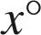,  and 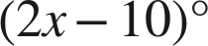.

6. An isosceles triangle's base angles are each 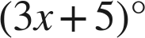 and the third angle is .

7. An exterior angle is ; its remote interior angles are 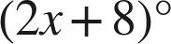 and .

Choose one.
8. A triangle's angles are 30°, 70° and 80°. What is the exterior angle beside the 80°?
○ A. 80°
○ B. 280°
○ C. 100°
○ D. 70°

9. Which equation finds x when an exterior angle is  and its remote interior angles are  and 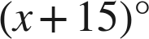?
○ A. 
○ B. 
○ C. 
○ D.

